

**Abell Improvement Association Newsletter**

April 2015

**www.abellimprovement.org**

|  |
| --- |
| **Inside:** |
| AIA Safety Committee Tips, Free Light Bulbs |
| Spring into Action: Community Engagement Challenge |
| Memorial Day Picnic |
| Peace & Quiet Reminders |

Dear Neighbors:

*To every season there is a purpose.*

Shaking off Winter. Cleaning house and yard. Beautifying the neighborhood. Finding one’s Mojo.

That’s what Spring is for. We hope the activities and opportunities covered in this Newsletter will assist neighbors in enjoying this loveliest of seasons.

At AIA’s **SPRING MEMBERSHIP MEETING (April 22, 6:30 P.M., 29th St. Community Center)** we will highlight 2 community resources for keeping in shape mentally, physically and spiritually: the **Harry and Jeanette Weinberg** **Family Center Y** and the **Shambhala Meditation Center.** Along with presentations from both, those in attendance will receive **free 5** **day passes to the Y.** At the same meeting members can weigh in on whether AIA should change the By-Laws to permit the association to hold more than 4 membership meetings a year and brainstorm about the kinds of meetings we should be planning.

**SATURDAY, APRIL 25 is the MAYOR’S SPRING CLEAN-UP**, an opportunity to work together on sprucing up alleys, sidewalks, yards and the Open Space.

Speaking of which: AIA is in the process of renewing the **Memo of Understanding between the association** **and Baltimore City regarding the Open Space**. The renewal process has reminded us that our beloved patch of green is owned by the city and governed by rules and laws that in recent times we have been lackadaisical about enforcing. The MOU waives some of the rules – certain usage fees, for example - in return for AIA upkeep of the space. But other requirements, including the prohibition of play equipment that is not approved for safety by the city, must now be accepted. This aspect of “spring cleaning” I lament along with the parents and children who are feeling bereft. But it’s still a great space where all are welcome, the swings are safe, there’s plenty of room for games, and for enjoying the company of friends. While this is true every day, **SUNDAY, MAY 24** we will gather there for our annual **MEMORIAL DAY PICNIC AT 5 P.M.** Please join us.

At our southern boundary other welcoming spaces beckon: **The** **Barclay Elementary-Middle School** and **The 29th Street Community Center.** Abell neighbors can link up with the young people, dedicated educators, Center staff and volunteers by helping with the **Barclay 5K Run on April 25,** joining the **Community Center’s 2nd Birthday Party on May 9,** sponsoring a week of the Co-Ed **Bulldog Basketball Camp** for a child this summer, or just dropping by and getting to know the great people and programs there.

We’ve waited a long time for this Spring. Let’s make the most of it!

Jo Ann Robinson

President, Abell Improvement Association



**Safety Committee Tips &**

**Free Light Bulb Distribution**

Safety experts agree that good lighting in residential areas discourages criminal activity. At our homes, the front and rear doors should be well lit. The AIA safety committee urges residents to *keep their porch lights on* at night. **Free light bulbs** are available. Contact Jo Ann Robinson at [jooiman@msn.com](mailto:jooiman@msn.com), if you wish to pick up light bulbs.

**Porch Presence**

When the weather is pleasant, why not spend some time in the evening on your porch, perhaps sharing a refreshing drink with your neighbors? The visible presence of people in a neighborhood helps deter crime. Besides, an evening of people-watching and chatting with your neighbors could be fun!

**When you are walking**, the Baltimore Police Department recommends:

* Use well-travelled, well-lit streets and paths.
* Travel in groups if possible.   
  If followed, head towards populated or open areas.
* Don’t allow texting or phone conversations to distract you from your surroundings.
* If a person in a vehicle bothers you, reverse direction and head to a safe, populated, well-lit place.

***To the Abell Community from Vonnie Gowe:***

I want to thank everyone who helped to care for our whole family in the past few months. Now we understand what **“It Takes a Village”** really means. And we are very grateful.

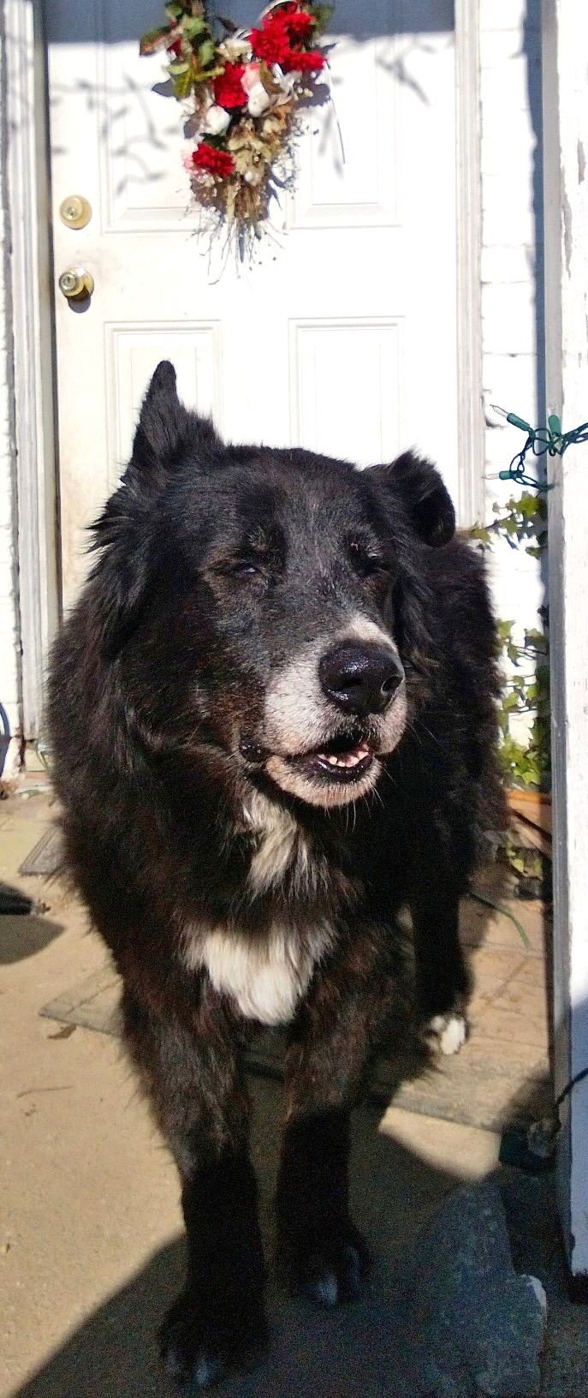

Connie Whiting said good-bye to Vito Poochenzo, age 15, who died on March 17. He was known to some in the neighborhood as "The Bagel Dog" because he sat in a chair at Sam's Bagels and ate breakfast when he was younger.

**Peace & Quiet Guidelines**

Abell residents are proud of their community’s sense of neighborliness. The AIA urges residents to abide by general community standards of peace and quiet. There are certain actions, considered by much discussion as well as by general consensus, to be “unacceptable behavior” in our neighborhood.

What constitutes unacceptable behavior? Here are some examples:

* Loud, boisterous voices or music that disturbs neighbors. This may be associated with a large gathering of people, a keg party, or a parked car.
* Drivers using car horns to get someone’s attention.
* Dogs that bark loudly and excessively.
* Any behavior that negatively affects the safety of residents, children, pets or visitors.

What should we expect from our neighbors?

* If you are expecting someone to pick you up, ask them to call when they arrive or come to your door. Explain in advance that they should not use their car horn to announce themselves.
* Street or porch conversations should be held at a low, private level, especially in good weather when windows are open.
* General quiet during the nighttime hours. This is considered 10 p.m. to 7 a.m. on weeknights and midnight to 7 a.m. on weekends.

**Congratulations to Our Grammy Winner**

Congratulations to Abell resident **Aaron Sheehan**, who won a Grammy in February for Best Opera Recording for his tenor part on “Charpentier: La Descente d’Orphee Aux Enfers.” Aaron has performed extensively in opera and chamber music productions in the US, Latin America and Europe. He has been nominated for Grammy awards twice before, and has appeared on a number of recordings. Aaron is currently on the voice faculties of Boston University, Wellesley College, and Towson University.

***2***

**2015 Abell Street Fair Set for September 20**

Hello Neighbors! The Abell Community Street Fair Committee is pleased to announce the date for this year's Fair: Sunday, September 20, from 12:00 p.m. to 5:00 p.m.

The Committee is led by Joel Urbanowicz and Haakon Maxwell again this year, and work has already begun to improve upon last year's excellent event.

The entire Committee will commence planning in earnest for the 2015 Fair with a kick-off meeting on Saturday, April 4th (time and location TBD) to which all volunteers are invited. Thereafter, planning sessions will be held every other week, right up to the Fair itself. It takes a lot of talent and effort to organize the Fair, so it should be no surprise that we are looking for community members who are interested in helping to produce the Fair. Several neighbors have already offered to reprise their role from last year, but we are still looking for individuals to assume leadership over various features of the Fair. Attendance at each and every planning session is not required, but we do need people who can attend the meetings more often than not, so that the entire effort is well coordinated.

Please consider making this year's Abell Community Street Fair better than ever by helping us in the months and weeks prior to the event.

Contact Haakon Maxwell (haakon.maxwell@gmail.com) or Joel Urbanowicz (urbanow2@gmail.com) if you are interested in volunteering.

Thank you,

Haakon and Joel

Dear Neighbors:

My name is Mikayla. I have been invited to travel to Europe as a Student Ambassador representing the United States on a trip provided by People to People Ambassador Programs. We will travel to seven countries in Europe from June 27 to July 16, 2015.

I want to be an author some day, and this trip will give me experiences that will be with me the rest of my life. I’m so excited to fly for the first time, visit Parliament in England, talk with a Normandy D-Day survivor, do a local service project, and stay with a host family in Germany. I will also visit London and Paris, where I will experience the art district of famous writers and painters and visit the Louvre. Tasting Belgian and Swiss chocolate won’t be too shabby either.

I need to raise $3000 for the trip by May 1, 2015. A friend who had known me since before birth has generously pledged $1500 when I raise $1500 to match it. If you can help me do this I will greatly appreciate it.

Contributions can be made by: payments to PayPal: 443-695-9299 or check payable to: Sandra Orem, 3004 Abell Avenue, Baltimore, MD 21218.

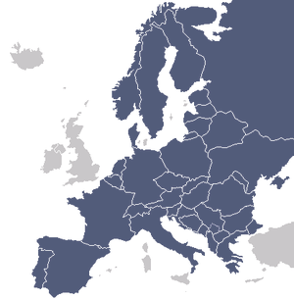

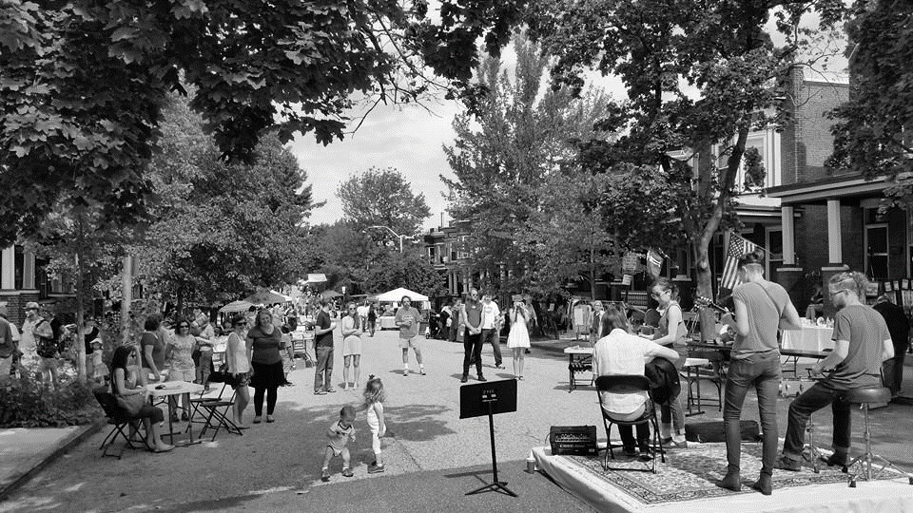

*Fairgoers enjoy music from the acoustic stage at the*

*Abell Street Fair 2014*

aBB

**Spring into Action – Get Involved with Your Community**

***3***

**Abell Group Marching for Babies**

Come join the Abell Community on May 9th for the annual **March for Babies** fundraising walk (4 miles starting at Camden Yards). Your support helps fund preventative research to help all babies be born healthy. Can't join the walk? You can still help by making a donation. Contact Miruna.patrascanu@accenture.com to sign up.

**Help Make Barclay’s 2015 “Girls on the Run” 5k a Success!**

Fifth Grade teacher Ms. Garcia needs volunteers to help with the 5K Run, sponsored by her girls’ running club, at the school on April 25 from 9:30 -noon. Adult supervision will be needed with pre- and post-race activities as well as with the run itself. Please contact her at [**magarcia@bcps.k12.md.us**](mailto:magarcia@bcps.k12.md.us)



GREAT TEACHER! GREAT KIDS!

GREAT WAY TO SPEND A MORNING.

**Barclay Bulldog Basketball Camp**

When: June 6 - July 3; July 7 - July 10

Who: Rising 4th-8th graders (Co-Ed)

Cost Per Student: $50.00 per week; includes morning snack and lunch.

To **sponsor one or more students**:

Contact

Coach Pablo Koropecky (443-904-0443)

or donate at this website:

https://bulldogbasketballschool**.** wordpress.com/donate/



**Spring Clean-Up at the Open Space**

At 12:00 p.m. on Saturday, April 25, AIA will sponsor an Open Space Clean-Up in conjunction with the Mayor's Spring Clean-Up. If you would like to help at the Open Space, please contact Haakon Maxwell (haakon.maxwell@gmail.com). Tools and other supplies will be provided, but bring your own work gloves.

**SPRING COMMUNITY ENGAGEMENT CHECK-LIST**

* + April 4 Street Fair Planning Meeting
  + April 22 Spring Membership Meeting
  + April 25 Mayor’s Spring Clean-Up
  + April 25 Barclay 5K
  + May 9 29th Street Community Center Birthday Party
  + May 9 Abell Group March for Babies
  + May 24 Memorial Day Picnic

**PRESIDENT’S CHALLENGE TO MEMBERS** (excluding the Executive Committee): Complete 5 of the above activities and enjoy a Weekend Brunch with me at Donna’s in June. Honor System: we will believe you if you say you were there – tho’ there could be a pop quiz before you’re allowed to order! If you’ve met the challenge contact me at the end of May: **jooiman@msn.com**

***4***

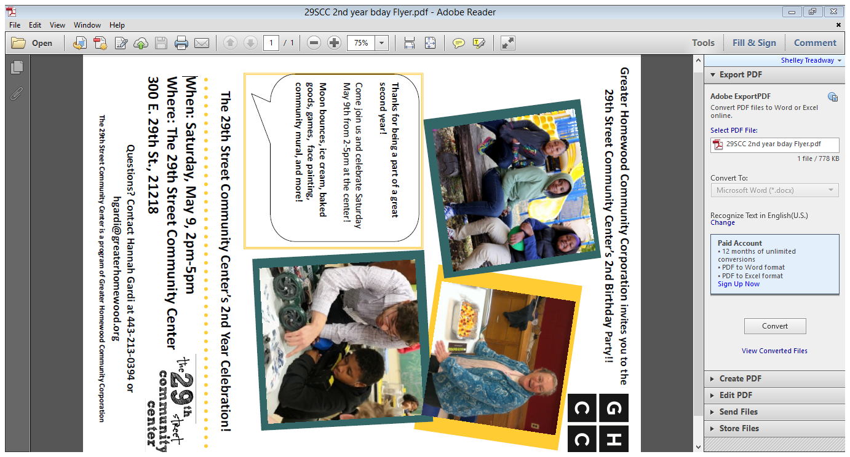

***5***

Trash & Recycling Schedule

**TRASH**

**EVERY TUESDAY**

**🙡**

**RECYCLING**

**EVERY THURSDAY**

Trash may be put out after

6 p.m. the night before, by

6 a.m. the day of pick-up.

*Trash must be in rigid containers with tight-fitting lids.*

**MAYOR’S SPRING CLEAN-UP AND**

**DUMPSTER DATE:**

**APRIL 25**

31st Street at Abell



Where neighbors come together

**300 East 29th Street, Baltimore, Maryland 21218 · (443) 213-0394**

**Programs for all ages have rolling enrollment! Check out our full listing of programs, events, and ways to get involved at *www.29streetcenter.org***

**Rent a Room at the 29th Street Community Center!**

Perfect for birthday party, baby showers, family reunions, and more!

**Community Room** (First Floor Large Room, max occupancy 40) - $50/hour

**Children’s birthday party package** - $120/2 hours (Community Room plus access to kitchen)

**Gym** (max occupancy 150) - $60/hour

**Multipurpose Room** (Second Floor Large Room, max occupancy 150) - $75/hour

**Memorial Day Picnic**

Sunday, May 24 ♦ 5 p.m.

Come enjoy an afternoon with your neighbors for hot dogs, hamburgers and drinks.

***Bring a dish to share.***

Abell Open Space

32nd Street between Abell & Guilford

**Officers Contact List**

Jo Ann Robinson, President

3012 Abell Avenue

jooiman@msn.com

Katie Flickinger,

Vice President

3131 Abell Avenue

kflicki1@gmail.com

Andy Scott, Treasurer

3034 Abell Avenue

410-889-1530

Ascottpsu02@Aol.Com

Linda Forlifer,

Recording Secretary

315 E. 33rd Street

410-243-1287

LForlifer@gmail.com

Jim Anthony,

Corresponding Secretary

3212 Abell Avenue

anthony@towson.edu

**- Bulletin Board -**



**Not a member yet?**

**No Problem!**

We have tons of programs for all ages and you do not have to be a member to get in on the fun. Swim, sports, karate, dance, art, rock wall, water fitness, take your pick!

Come check out your local Y -the Weinberg Family Center at 900 E. 33rd St.

Baltimore MD, 21218

www.ymaryland.org

410-889-9622

**Free 5-day membership passes will be available at the April 22 AIA Membership Meeting.**



**AIA Quarterly Membership Meeting**

Wednesday, April 22

6:30 p.m.

TOPICS TO INCLUDE:

1. Presentations on Weinberg Y  
    and Shambhala Center
2. Vote on proposed By-Laws change to permit more than 4 meetings/year.
3. Brainstorm themes for future meetings

Light Snacks will be served.

**29th Street Community Center**

**300 East 29th Street**