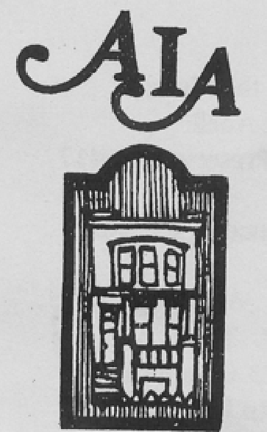

Abell Improvement Association Newsletter

September 2014
★ STREET FAIR EDITION 
PRESIDENT’S MESSAGE
Dear Neighbors:
I hope you have all had an enjoyable summer. The AIA outdoor film series has been very popular this year. I hope that you have been able to take in a few movies.
The annual Abell Community Street Fair, our biggest event of the year, is coming up in just a few weeks. This year the fair is on Sunday, September 21, from noon to 5 p.m. in the 3000 and 3100 blocks of Abell Avenue. Haakon Maxwell and Joel Urbanowicz are co-chairing the Street Fair this year, and they have some great stuff in store for us! This year’s fair includes everything you’ve come to expect: a Crab Feast (ticket order form inside this newsletter on p.2), Baltimore’s Best Silent Auction, and fabulous local artists and vendors. We will have two stages this year, the main stage at 32nd and Abell, and an acoustic stage at 30th and Abell. Music on the main stage will include Super City, Timothy Bracken Complex, Hollywood Blanks, and DJ Mills. We will also have great kids’ activities including the Children’s Parade (Greek Mythology themed this year!).
The Street Fair is also the AIA’s biggest fundraiser. We use the proceeds from the Fair to pay for the programs, events, and activities that make our community stronger. Over the past year, these have included funding a Mini-Grants Program for teachers at the Barclay School, printing our AIA Newsletter, paying the licensing fees that allow us to show movies during our Summer Film Series, as well as hosting a variety of get-togethers, picnics, and other social events. By supporting the Street Fair, you make these things possible.
Please consider volunteering at the Street Fair. Inside, you will find more information about how you can help, and how to sign up to help on the day of the Fair. It’s a really fun day. And even if you volunteer for a couple of hours, there is still plenty of time for you to wander around and enjoy everything at the Fair. We also still have space for vendors and exhibitors. Please send an email to abellstreetfair@gmail.com if you know of any vendors who might be interested in having a table. Or, consider donating something to our Silent Auction. We’re always looking for high-value services or items to add to the auction table.
However you choose to do it, I hope you’ll consider contributing to this year’s event. And of course, we’ll look forward to seeing you at the Fair on September 21.
In service,
Bonnie Bessor
President, AIA

Inside:
Abell Street Fair
★
Children’s Parade
★
Silent Auction
★
Bake Sale
★
Crab Feast
Residential Parking Permits
29th Street Community Center: Volunteering, Robotics

✶   PARKING REMINDER   
In preparation for the Street Fair, all residents are required to move vehicles from the 3000 & 3100 blocks of Abell Avenue and the 300-400 blocks of 32nd Street between 8 a.m. and 6 p.m. on Sunday, September 21. Free parking is available on the northeast corner of Barclay and 32nd Street.

Many thanks to Peabody Heights Brewery and Johns Hopkins University for sponsoring the 2014 Street Fair!
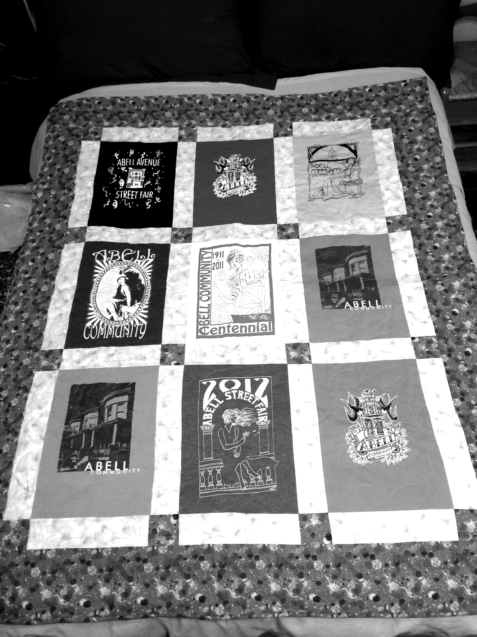
Bake a Yummy Treat for the Bake Sale
The bake sale is a treasured feature of the Abell Community Street Fair. You can help us continue the tradition by donating cakes, pies, cupcakes, cookies, brownies, breads or pastries. We pride ourselves on offering treats made with love in or own kitchens, so please, homemade items only. We cannot accept store-bought items. If you would like to contribute baked goods, please contact Haakon Maxwell email: haakon.maxwell@gmail.com phone: 443.980.0610

2013 Silent Auction item – original handmade quilt by Kathy Flickinger made from past Abell Fair tee shirts

Got junk?
Stoop sales will be alive and popular at the 2014 Street Fair. Now is the time to get rid of your junk and the next person's treasure. If on 3000/3100 blocks of Abell Avenue, simply set up on your porch and steps! For those not on the Avenue, there will be space in the street on the 3000 block reserved for those who sign up in advance. Signing up is free. To sign up, and to reserve a table rental ($10 - optional), please email Sindbad Fennimore at ssf8@georgetown.edu. Happy hunting, and good luck!

Crab Feast
The 2014 Street Fair includes a CRAB FEAST as always, but with a new option for appetites that may be on a budget or that just crave a few morsels rather than the traditional all-you-can-eat portions. Crab lovers in both categories can save by ordering in advance by Friday, September 19. On the day of the Fair prices will be 3 crabs for $10.00 or All You Can Eat for $36.00. Advance orders are discounted: 3 crabs for $7.50 and All You Can Eat for $30.00. ORDER NOW using the form below; deliver with payment to 3012 Abell Avenue c/o Jo Ann Robinson. Make checks payable to Abell Improvement Association.

AIA 2014 STREET FAIR CRAB FEAST ORDER FORM
Sunday, September 21, 2014 ▪ 1 p.m. – 5 p.m.
Pay in advance by Friday, September 19
2

Number of orders for 3 crabs: _________ x $ 7. 50 = ___________
No. of all-you-can-eat orders: _________ x $30.00 = ___________
Payment Total Enclosed: ___________

Name: __________________________________________________________________

Address______________________________________ phone or email___________________________
Please return with check made out to Abell Improvement Association or cash to:
Jo Ann Robinson • 3012 Abell Avenue

2014 Abell Community Street Fair

Sunday, September 21, Noon - 5:00 p.m.
The Abell Community Street Fair is produced entirely by neighbors and friends who donate their time and talents. If you haven’t had a chance to lend a hand yet, there’s still plenty to do. We need volunteers and donations for the following activities:
- Set up & clean up: Early in the day, we need a team to distribute tables, erect canopies, and wrestle the stage pieces into place. Late in the day, we need folks to strike the same and clean up the fairgrounds. Please contact Haakon Maxwell if you can serve in this capacity. (Email: haakon.maxwell@gmail.com or phone: 443-980-0610)
- The bake sale needs homemade cakes, pies, cupcakes and cookies. We would like to offer coffee and fresh lemonade; put your percolators and juicers into service.
- We are always looking for outstanding items for our Silent Auction. Please contact Linda Forlifer (email: lforlifer@gmail.com or phone: 410-243-1287) about making a contribution to the Silent Auction. And don’t forget to drop by and place a bid or two.
- The Fair will offer many activities for children, starting of course with the Children’s Parade that is the ceremonial opening of the Fair. This year the Parade theme will be Ancient Greek Mythology. Get ready for adorable Medusas and cute, happy little Minotaurs. Arts and craft supplies and other items that might help us make costumes, floats, and the like would be gratefully accepted. We are especially in need of oversize boxes. Go buy that stove you’ve been coveting now, so we can have the box in time to paint it! Please contact Carol Serksnis (email: carol_serksnis@yahoo.com or phone: 443-629-8004) regarding donations for the Children’s Parade and other Children’s Activities.
- Finally, we need people to serve in many varied roles throughout the day. The chart below gives an idea of the volunteer opportunities. Whether you are interested in serving as a parade marshal (only a 15 minute commitment!), selling homemade Baked Goods, or painting beautiful little faces, please contact Haakon Maxwell (email: haakon.maxwell@gmail.com or phone: 443-980-0610). Remember: do not leave cars parked on the 3000 and 3100 blocks of Abell or the 300 block of E. 32nd Street on the Sunday, September 21.
STREET FAIR VOLUNTEERS - How, When and Where Would You Like to Help?
 | Music | Crab Feast | Bake Sale | Membership Table | Silent Auction | Children's Activities,  Face Painting
10:00 | Assemble Stage | Distribute tables & chairs; assemble tents, canopies for all activities
11:00 |  | Set up tables & chairs, drink station | Accept donations; Make coffee | Set up table, shirt display | Set up display | Parade Marshals/Crossing Guards
12:00 |  | Manage Crab Feast | Manage sales | Manage sales | Accept bids | Parade - kids & parents to be in parade  Face painter
1:00 |  |  |  |  |  | Face painter
2:00 |  | Manage Crab Feast | Manage sales | Manage sales | Accept bids | Face painter
3:00 |  |  |  |  |  | Clean up
4:00 |  |  | Manage sales & clean up | Manage sales | Distribute winnings
5:00 | Strike stage | Clean up | Clean up | Break down | Break down
6:00 | Finish clean up; stack tables and chairs; consolidate trash

3

Benefits District Seeks Quad #4 Representative
Would you like to represent your neighbors to the Benefits District? The Charles Village Community Benefits District Management Authority is looking for someone to represent the northeast quadrant of the District (Quad #4). The current representative, Kirsch Jones, has reached the end of his term. The duties are to attend one Board meeting and one committee meeting per month and to communicate with your neighbors about their concerns. You need to attend the Quad Reps Election on Tuesday, October 14, 6:00 p.m. (location TBD). For information, please call Susanne Riveles at 410-467-2721, Emil Volcheck at 410-929-3399, or Jim Anthony at 410-243-2269; or email Kirsch Jones at president@charlesvillage.org.

Abell Neighborhood Walkers
Join the Abell Neighborhood Walkers! Meet friends and help reduce crime in our neighborhood! Come to the Open Space Thursday evenings at 8:30 to help patrol our neighborhood. We walk on second and fourth Thursdays. For details, call Emil Volcheck at (410) 929-3399 or email at volcheck@acm.org .
After-School Robotics Program at the 29th Street Community Center
This year, the 29th Street Community Center will continue its partnership with the Johns Hopkins University Center for Educational Outreach to host a fun and engaging after-school robotics program for middle and high school-age students. The program begins September 29th and will meet at the community center on Mondays and Wednesdays, from 4 to 6pm.
Students will work with the JHU Baltimore Robotics Institute to construct robots from scratch and they will use their robots to play an arena style game created by VEX Robotics. In addition, they will have opportunities to compete in Baltimore VEX competitions throughout the year.
Students will master the basics of robotics, as well as science and math principles applicable at home and in school. Through playing the game and working to improve their robots, students will ascertain the importance of teamwork and develop problem-solving and critical-thinking skills.
The 29th Street Community Center team had a very successful first year and we are excited for an equally successful second season. If you know a middle or high school student that has an interest in science, technology, engineering, or math and wants to learn more about robots, please contact Margaret Hart, the Middle School STEM Program Manager from the Center for Educational Outreach, at Robotics.Coordinator@jhu.edu.

4

Inspire the Next Generation: The 29th Street Community Center is seeking after-school program volunteers.
Where: The 29th Street Community Center, 300 E. 29th Street, Baltimore MD 21218
When: 2:00-5:30 p.m. Monday-Thursday
Who: young people in K-8th grade
How you can help inspire our youth:
- Provide homework help and consistent support to neighborhood youth
- Read with kids, tutor in math, help with science projects
- Share your talents and skills with kids through weekly activities
- Inspire them to try something new
- Teach cooking classes
- Get outside with them – coach a team, lead field games, promote team building
We are seeking consistent volunteers who can commit to serving once or twice a week from 2:00 - 5:30 p.m. We will provide volunteer training and support along the way. Join our team in serving incredible children!
For more information contact:
Hannah Gardi, Director
29th Street Community Center
hgardi@greaterhomewood.org 443-213-0394
4

RENEWAL & PICK-UP for
Residential Permit Parking (RPP) Area 12/12A
All RPP permit renewals paid by credit card or check PRIOR to October 15
will be available to pick up at these outdoor distribution sites:
Saturday, October 18
WAVERLY FARMERS MARKET from 9 a.m. to noon
Table on 32nd Street by Barclay Street
EDDIE’S MARKET from 1 p.m. to 4 p.m.
Table at 3117 St. Paul Street
PLEASE NOTE: YOU MUST BRING A PHOTO ID!

Register online after September 20 for RPP Area 12 Charles Village & Abell 12A Permits.
After October 18, you MUST go downtown to the city’s Parking Authority office to pick up your permit.
Residents of Charles Village in the Residential Permit Parking (RPP) Area 12 (north of 29th Street, west of Hunter Street/alley) and 12A-Abell (north of 29th Street, east of Hunter Street/alley) must register and purchase their annual parking permits and visitors passes.
All current permits expire October 31. You must show proof of residency to ensure that participation in the program is limited to residents only. To be eligible for a Parking Permit and/or Visitors Pass, you must reside within the boundaries of the RPP area. Warning - a parking citation (fine) for not displaying a current RPP decal or visitor’s pass in Area 12/12A is $52 for each occurrence.

For general information about the RPP Program and its rules and regulations, go to:
http://www.baltimorecity.gov/Government/QuasiAgencies/ParkingAuthority/ResidentialParkingPermits.aspx

You can then access the RPP application site, general rules and regulations, step by step instructions (click on RPP Application site first to see step by step instructions), required documentation and Frequently Asked Questions. If you do not have internet access, you may go to the Village Learning Place, 2521 St. Paul Street, to use a computer in the library for applying online.
To renew your permit online, you can go directly to this secure site: https://pabc.t 2hosted.com/cmn/auth.aspx

Baltimore City’s annual Residential Parking Permits cost:

$20 for a Parking Permit (decal) $20 for a Visitors Pass
If you currently have a parking permit, you are already in the City’s RPP database and you do not have to re-enter your information. Use the same user name and password that you used last year. If you have forgotten your user name and/or password, call the Parking Authority at 443.573.2800 and staff will help you reset your password.
If this is the FIRST TIME you are applying for a parking permit, you MUST go downtown to the Parking Authority office at 200 W. Lombard Street, Suite B, to apply for and pick up your parking permit in person. The Parking Authority will provide you with validation to park for free in the garage above their office.
For additional details about RPP registration and renewal process, go to www.charlesvillage.net. You will find links to key portions of the Baltimore City RPP website and access step-by-step instructions on how to renew your permit.
Thanks to community volunteers, Eddie’s Market and the Waverly Farmers Market for making the RPP community pick-up possible on October 18. Please show your kind appreciation for all their generous assistance. Thank you for being courteous throughout the registration process.
Volunteers from the community make it possible for the CVCA and AIA to continue the convenient distribution of the RPP permits in the neighborhood on October 18. To volunteer to help with distribution on October 18, please contact RPP Area 12/12A Representative, Tim Behnam, at timbehnam@yahoo.com.
NOTE - The information above only applies to Residential Parking Permits and Visitors Passes in AREAS 12 and 12A (Charles Village and Abell). Charles Village WEST (Area 37) renewal and pick-up takes place in March, 2014. Area 37 is defined as west of Charles Street between 26th Street and 29th Street, including the unit block of E. 26th Street.

5

- Bulletin Board -
New Member Social and Chili Cook-off

All residents of Abell are welcome
Come meet your new neighbors and enjoy a bowl of hearty chili with all the fixin’s

Inside:
Abell Street Fair
★
Crab Feast
★
Silent Auction
★
Bake Sale
★
Children’s Parade
29th Street Community Center: Volunteering, Robotics
Residential Parking Permits

Abell Improvement Association Newsletter

September 2014
PRESIDENT’S MESSAGE
Dear Neighbors:
I hope you have all had an enjoyable summer. The AIA outdoor film series has been very popular this year. I hope that you have been able to take in a few movies.
The annual Abell Community Street Fair, our biggest event of the year, is coming up in just a few weeks. This year the fair is on Sunday, September 21, from noon to 5 p.m. in the 3000 and 3100 blocks of Abell Avenue. Haakon Maxwell and Joel Urbanowicz are co-chairing the Street Fair this year, and they have some great stuff in store for us! This year’s fair includes everything you’ve come to expect: a Crab Feast (ticket order form inside this newsletter), Baltimore’s Best Silent Auction, and fabulous local artists and vendors. We will have two stages this year, the main stage at 32nd and Abell, and an acoustic stage at 30th and Abell. Music on the main stage will include Super City, Timothy Bracken Complex, Hollywood Blanks, and DJ Mills. We will also have great kids’ activitie,s including the Children’s Parade (Greek Mythology themed this year!).
The Street Fair is also the AIA’s biggest fundraiser. We use the proceeds from the Fair to pay for the programs, events, and activities that make our community stronger. Over the past year, these have included funding a Mini-Grants Program for teachers at the Barclay School, printing our AIA Newsletter, paying the licensing fees that allow us to show movies during our Summer Film Series, as well as hosting a variety of get-togethers, picnics, and other social events. By supporting the Street Fair, you make these things possible.
Please consider volunteering at the Street Fair. Inside, you will find more information about how you can help, and how to sign up to help on the day of the Fair. It’s a really fun day. And even if you volunteer for a couple of hours, there is still plenty of time for you to wander around and enjoy everything at the Fair. We also still have space for vendors and exhibitors. Please send an email to abellstreetfair@gmail.com if you know of any vendors who might be interested in having a table. Or, consider donating something to our Silent Auction. We’re always looking for high-value services or items to add to the auction table.
However you choose to do it, I hope you’ll consider contributing to this year’s event. And of course, we’ll look forward to seeing you at the Fair on September 21.
In service,
Bonnie Bessor
President, AIA

Trash & Recycling Schedule
TRASH
EVERY TUESDAY

RECYCLING
EVERY THURSDAY
Trash may be put out after
6 p.m. the night before, by
6 a.m. the day of pick-up.
DUMPSTER
September 13
October 4
E. 31st and Abell Avenue
arrives approx. 8 a.m.
or earlier

Officers Contact List
Bonnie Bessor, President
412 E. 31st Street
410-916-1062
bbessor@gmail.com

Katie Flickinger,
Vice President
3131 Abell Avenue
kflicki1@gmail.com

Andy Scott, Treasurer
3034 Abell Avenue
410-889-1530
ascottpsu02@aol.com

Jo Ann Robinson
Recording Secretary
3012 Abell Avenue
jooiman@msn.com

Linda Forlifer,
Corresponding Secretary
315 E. 33rd Street
410-243-1287
LForlifer@gmail.com

www.abellimprovement.org
AIA Membership Meeting
Wednesday, November 19
6:30 p.m.
29th Street Community Center
300 E. 29th Street
Please send newsletter contributions to Shelley Treadway, 3026 Abell Avenue, or email to sbtreadway@aol.com.
Deadlines for submissions:
November 17 - Holiday Issue
January 17 - Winter Issue
★ STREET FAIR EDITION 

ABELL COMMUNITY
STREET FAIR 2014
Sunday, September 21
Noon - 5:00 p.m.
★ Children’s Parade  Food & Bake Sale 
Craft Vendors  Children’s Activities  Stoop Sale
★ Crab Feast  Live Music  Silent Auction 
3000 and 3100 Blocks of Abell Avenue
and the 300-400 blocks of 32nd Street

To volunteer, see page 3 for contact information.

Sunday, October 5  4:00 p.m.
Abell Open Space – 32nd St. between Abell & Guilford

NO PARKING IN THESE BLOCKS
8 A.M. – 6 P.M. ON SUNDAY, SEPTEMBER 21

✶   PARKING REMINDER   
In preparation for the Street Fair, all residents are required to move vehicles from the 3000 & 3100 blocks of Abell Avenue and the 300-400 blocks of 32nd Street between 8 a.m. and 6 p.m. on Sunday, September 22. Free parking is available on the northeast corner of Barclay and 32nd Street.

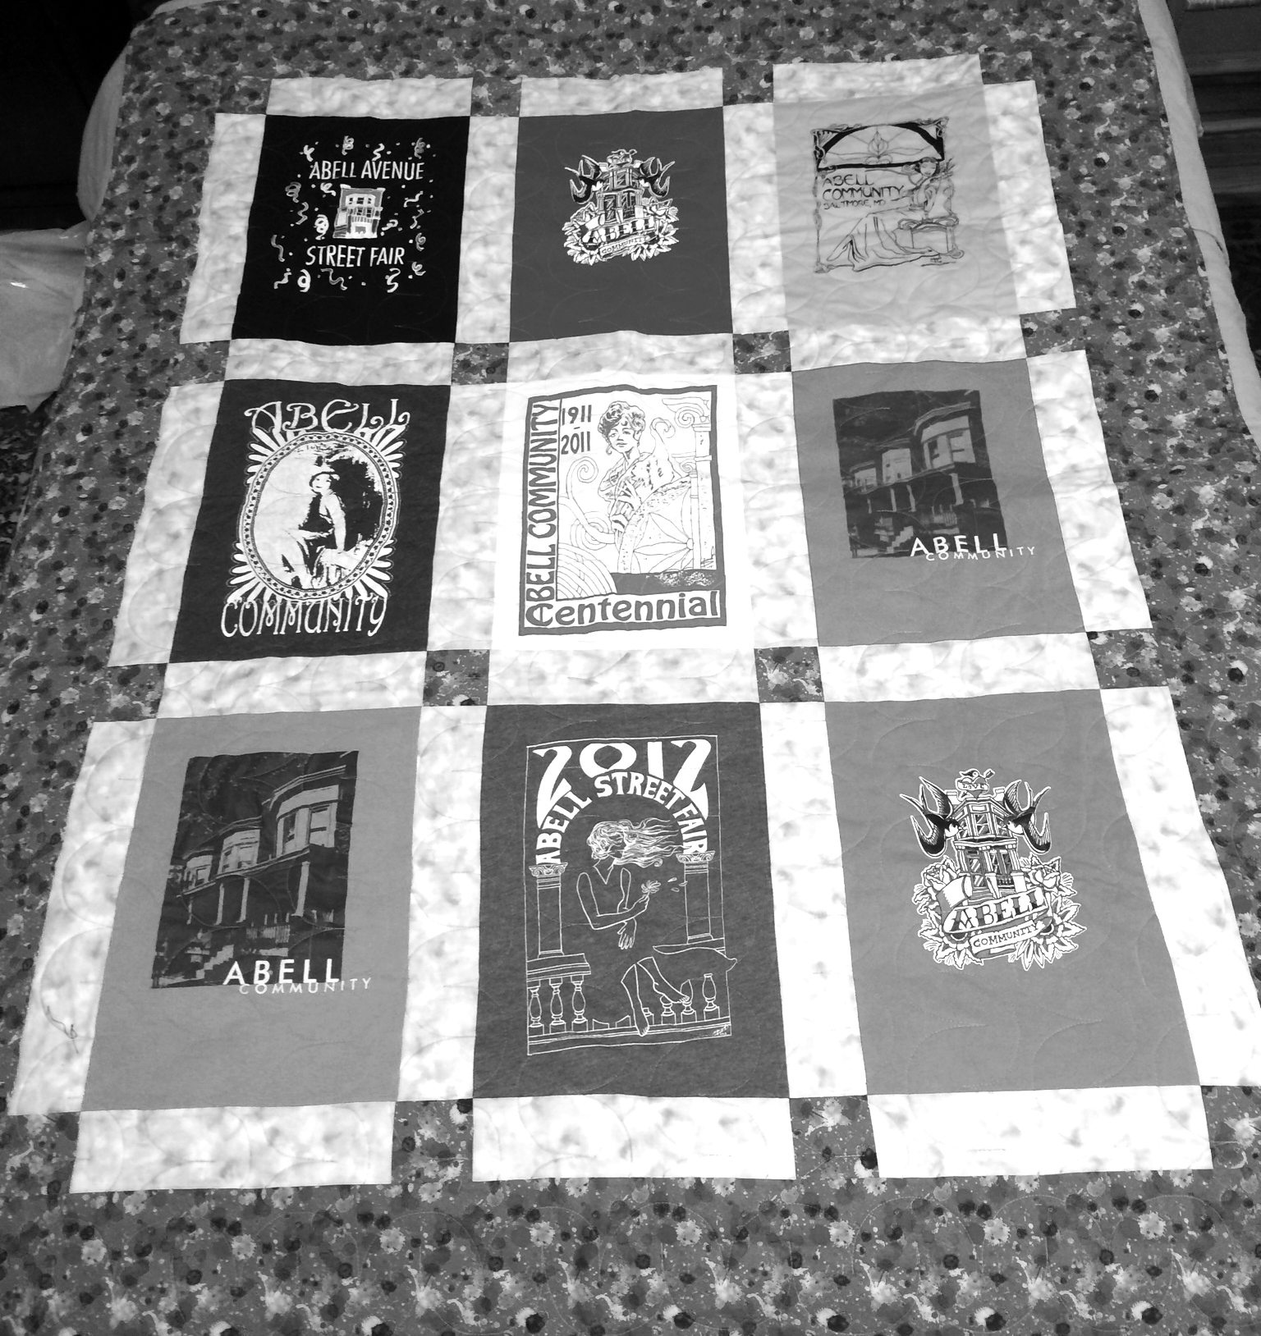
2
2

